Mrs. Stephanie & Mrs. Freedom’s Newsletter
April 12, 2024
What’s happening in our room?
It’s been a week of reviewing 3d shapes. My groups found them in magazines, cut them out and glued them onto poster paper, and Mrs. Freedom’s groups reviewed graduated order and tracking print. Next week is simple addition and subtraction.
What’s coming up:
May 6 – End of the year class picnic (more info to come)

May 9 – Student led conference nigh (I’ll contact you w/ times)

May 14 – YMCA Swim Day

May 17 – Last Day of School

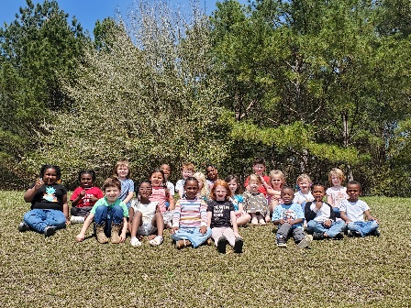
Need me?
sconnally@tcjackets.net Seesaw or 229-225-3908

